Terza Giornata di Approfondimento in Neuroscienze
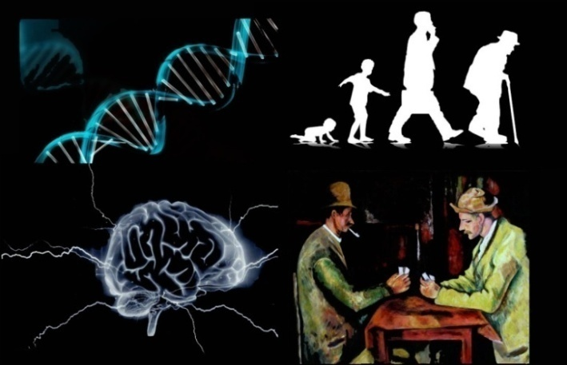
Genetics of Brain Disorders @ Department of Molecular Biotechnology, TORINO

May 29 aula Leonardo
9.00 – 10.00 Dr. Michèle Studer – Main Presentation

Additional lectures on the topic:

10.00-10.30 Federico Bianchi (Torino)
10.30-11.00 Maurizio Giustetto (Torino)
Break
11.30-12.00 Cecilia Mancini (Torino)
12.00-12.30 Maria Passafaro (Milano)

Lunch Break

14.00 – 17.00
Round table with the PhD students on the topics of the morning. This activity is reserved for those who are registered, in particolar Ph.D students. Morning speakers are wellcome to attend

May 30 Meet the Scientist
Dr. Michèle Studer will meet PhD students and their P.I. (1 hr each - 4 slots available). The conversation will focus on scientific data, publication perspectives, future plans, etc.. PLEASE RESERVE YOUR SLOT

Morning (2 slots)
9.30 - 11.00 Federico Bianchi
11:30 -13:00 Valeria Poli
Afternoon (2 slots)
14.00-16.30 free / free

May 31 Emerging Technologies in Neuroscience @ MBC aula Leonardo

Lectures on technological advances, followed by discussion
9:30-10:15 Optogenetics and two-photon microscopy (Serena Bovetti - Genova)
10:15-11:00 Bioinformatics and Brain Disease (Ferdinando DiCunto - Torino)
11:00-11:45 Measures of synaptic signals in central neurons (Andrea Marcantoni - Torino)
11:45-12:30 Imaging in Whole Brain (Paolo Giacobini - France)

